|  |
| --- |
| EPAM Systems, RD Dep., RD Dep. |
| MTN.*NIX.11 Automated Environment Configuration Management  **Ansible. 3** |

|  |  |  |  |  |  |
| --- | --- | --- | --- | --- | --- |
| REVISION HISTORY | | | | | |
| Ver. | Description of Change | Author | Date | Approved | |
| Name | Effective Date |
| <1.0> | Initial revision | Siarhei Beliakou | 17-Mar-2017 |  |  |
|  |  |  |  |  |  |

# Lab Work Task. Web Server Provisioning

# Review

Developing custom modules and filters. Learning by doing.

# Task

On Host Node (Control Machine):

1. Create folder ~/cm/ansible/day-3. All working files are supposed to be placed right there.
2. Develop custom filter to select an url to download mongodb depends on OS name and S/W version from <https://www.mongodb.org/dl/linux/>  
   Requirements:  
   - Write a playbook (name: **mongodb.yml**) to prove that this module works  
   - At least 9 versions of MongoDB for 3 different Linux distributives (list with links)  
   - Filter should process a list of urls and takes 3 options: os_family (discovered by ansible, variable, produced by setup module), os release number and mongodb_version (set in play vars)  
   See example in Appendix A

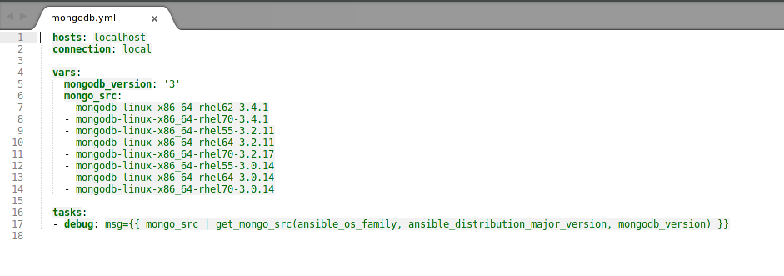

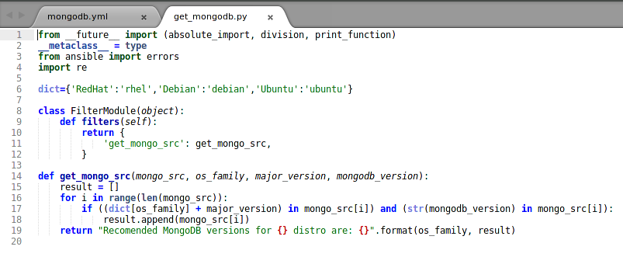

1. Develop custom module to manage VirtualBox:  
   Arguments:   
   - path to vagrantfile  
   - state: started, stopped, destroyed  
   Return values:  
   - state: running, stopped, not created  
   - ip address, port  
   - path to ssh key file  
   - username to connect to VM  
   - os_name  
   - RAM size  
   Errors:  
   - file doesn’t exists  
   - failed on creation  
   - etc

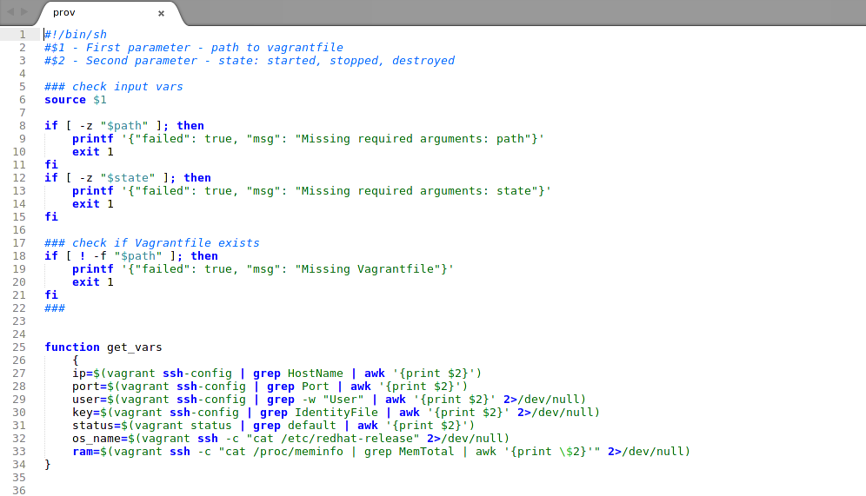

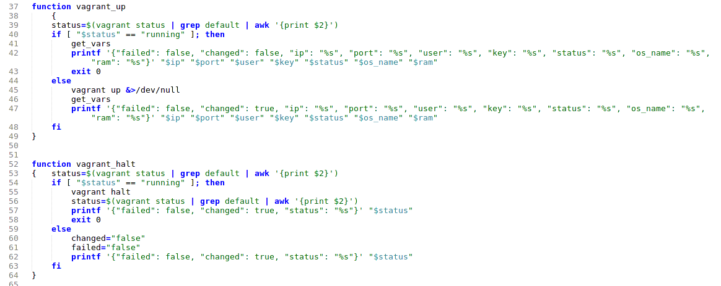

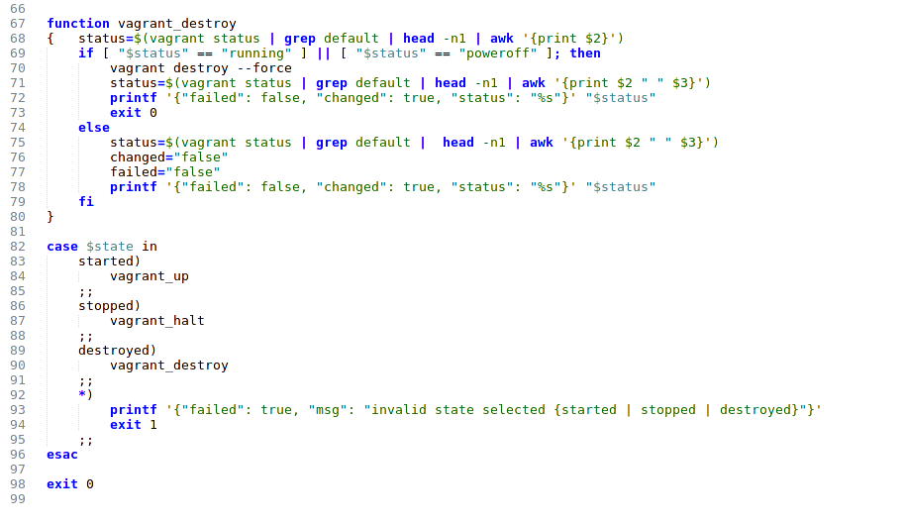

1. Create a playbook (name: **stack.yml**) to provision Tomcat stack (nginx + tomcat) on VirtualBox VM  
   Requirements:  
   - 2 Plays: provision VM, roll out Tomcat stack (using roles from previous lab work)  
   - 2nd play should work with dynamically composed Inventory (connection settings to VM), <http://docs.ansible.com/ansible/add_host_module.html>

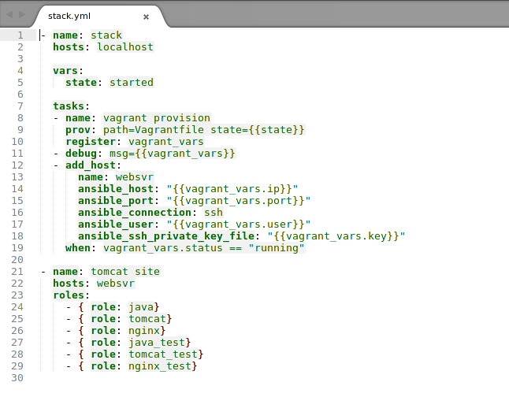

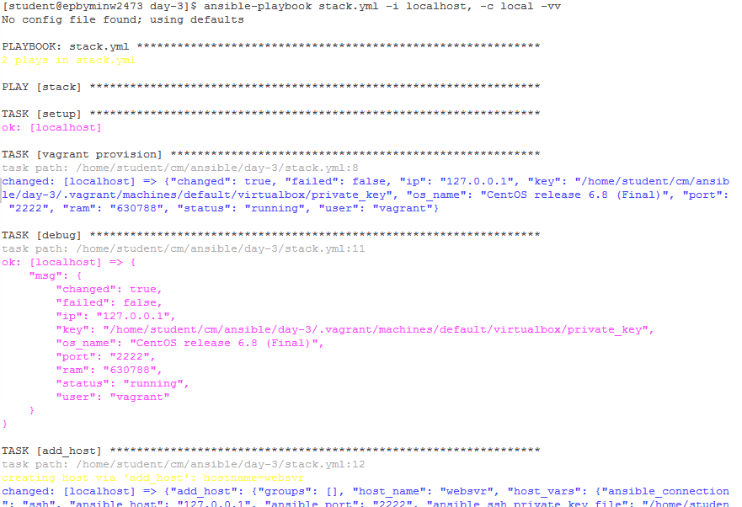

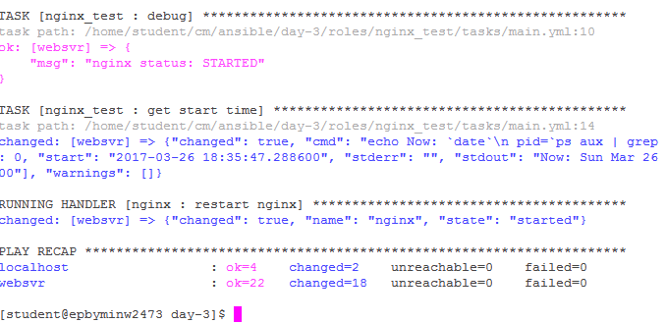

Second run of playbook

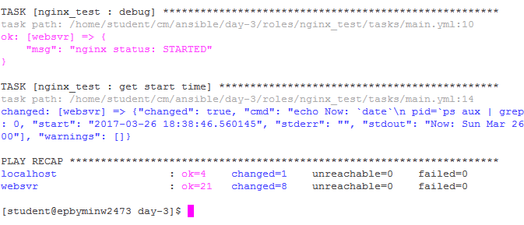

1. Verification Procedure: playbook will be checked by instructor’s CI system as follows:
   1. Connect to student’s host by ssh (username “student”) with own ssh key.
   2. Go into the folder mentioned in point 1
   3. Destroy: vagrant destroy
   4. Execute VM provisioning: ansible-playbook stack.yml -i localhost, -c local -vv
   5. If previous steps are done successfully, instructor will check report (pdf-file)
2. Feedback: report issues/problems you had during the development of playbook and time spent for development.

**APPENDIX A.**

Playbook:

- hosts: localhost

connection: local

vars:

mongo_src:

- mongodb-linux-x86_64-rhel62-3.4.1

- mongodb-linux-x86_64-rhel70-3.4.1

- mongodb-linux-x86_64-rhel55-3.2.11

- mongodb-linux-x86_64-rhel64-3.2.11

- mongodb-linux-x86_64-rhel70-3.2.17

- mongodb-linux-x86_64-rhel55-3.0.14

- mongodb-linux-x86_64-rhel64-3.0.14

- mongodb-linux-x86_64-rhel70-3.0.14

tasks:

- debug: msg={{ mongo_src | get_mongo_src("rhel", "7", "3.2" ) }}

- debug: msg={{ mongo_src | get_mongo_src("rhel", "6", "3.0" ) }}

- debug: msg={{ mongo_src | get_mongo_src("rhel", "7", "3.4" ) }}

Run:

$ ansible-playbook test1.yml -vv

Using /Users/sbeliakou/.ansible.cfg as config file

[WARNING]: Host file not found: /etc/ansible/hosts

[WARNING]: provided hosts list is empty, only localhost is available

PLAYBOOK: test1.yml ************************************************************

1 plays in test1.yml

PLAY [localhost] ***************************************************************

TASK [setup] *******************************************************************

ok: [localhost]

TASK [debug] *******************************************************************

task path: /private/tmp/test1.yml:19

ok: [localhost] => {

"msg": "mongodb-linux-x86_64-rhel70-3.2.17"

}

TASK [debug] *******************************************************************

task path: /private/tmp/test1.yml:20

ok: [localhost] => {

"msg": "mongodb-linux-x86_64-rhel64-3.0.14"

}

TASK [debug] *******************************************************************

task path: /private/tmp/test1.yml:21

ok: [localhost] => {

"msg": "mongodb-linux-x86_64-rhel70-3.4.1"

}

PLAY RECAP *********************************************************************

localhost : ok=4 changed=0 unreachable=0 failed=0